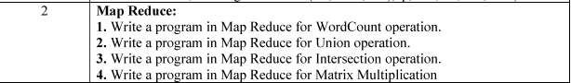

1. MapReduce Program for WordCount
https://drive.google.com/drive/folders/1Wuz11VkXJi3EjTUYvJNUfzjEaSYRrYv7

